Firewall ConfigurationsTheory (1 hour):Basics of firewalls and ufw/iptables in Linux.Creating rules for inbound and outbound traffic.Practical (1 hour):Configure ufw to allow SSH and block other services.Task: Document the configured firewall rules.
Tasks
1.Install ufw on your Linux system (if not already installed) and enable it, then verify its status using the appropriate commands.

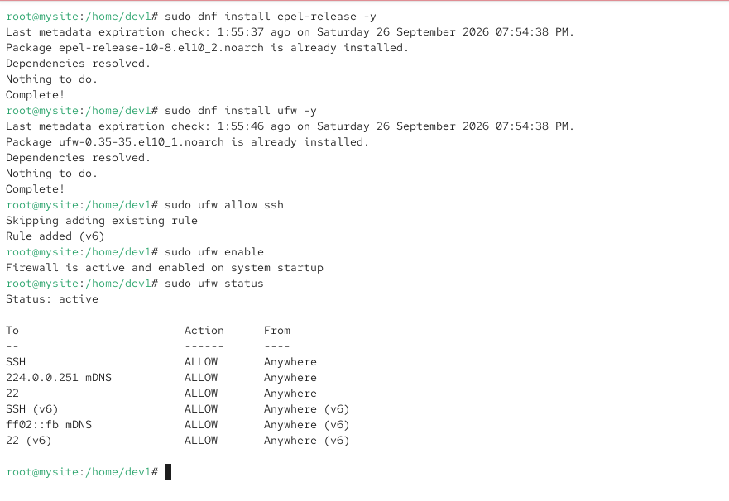
2.Configure ufw to allow incoming SSH connections only on port 22 and block all other incoming connections.

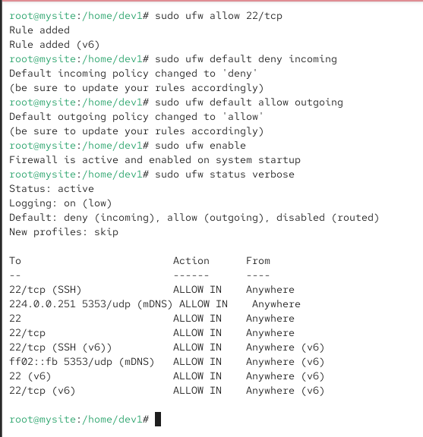
3.Add a rule in ufw to allow outgoing HTTP and HTTPS traffic (ports 80 and 443), but block all other outbound connections.Hint: Use 'ufw allow out' and 'ufw deny out' commands to control outbound traffic.

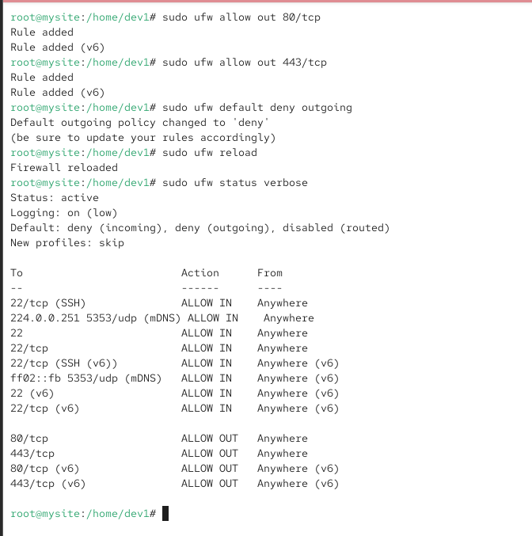
4.List all currently active ufw rules on your system and save the output to a file named firewall_rules.txt.

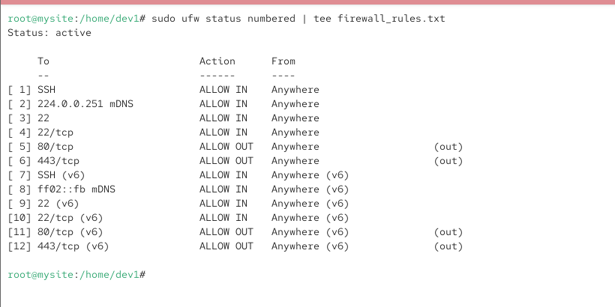
5.Write a short explanation (3-4 lines) describing how your current ufw configuration would impact running a local web server (like a development server for a Zomato-style food delivery app).
If UFW allows only SSH (22), HTTP (80), and HTTPS (443), a local development server on another port such as 3000 or 5000 will be blocked from other machines.
The Zomato-style app can still run locally on the server using localhost.To access it from other devices, the required application port must be allowed in UFW.SSH access on port 22 will remain available for remote administration.

